WEEK-3

Exercise 4: Creating and Configuring a Maven Project

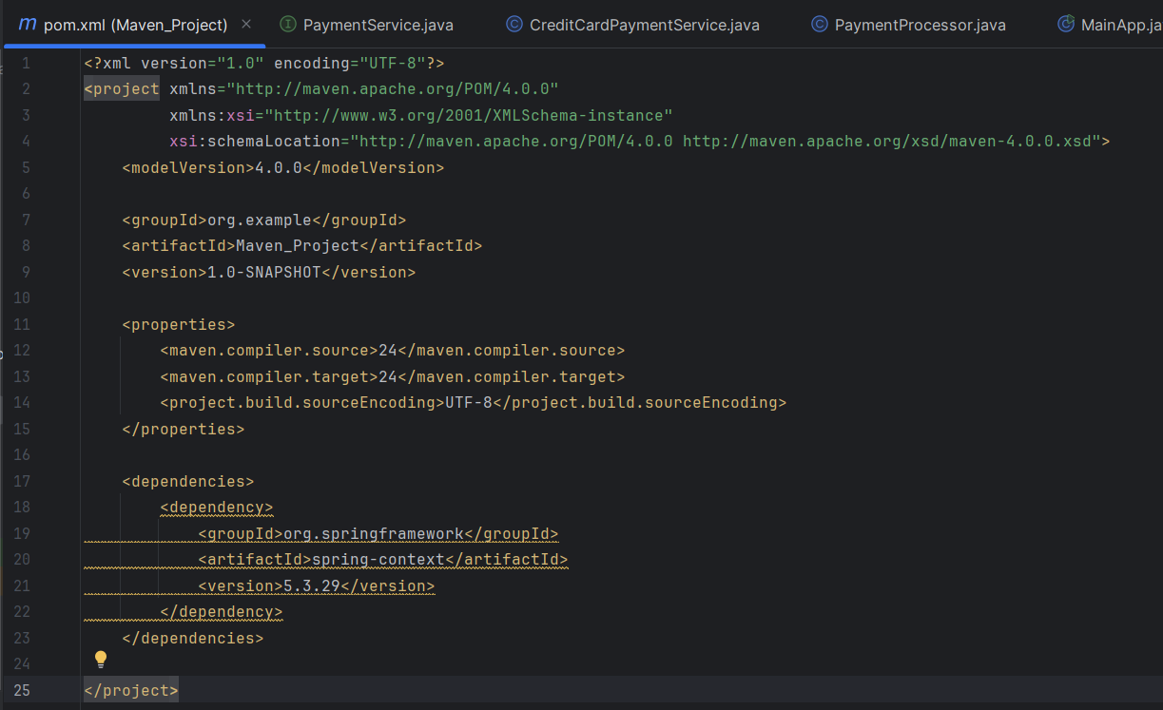

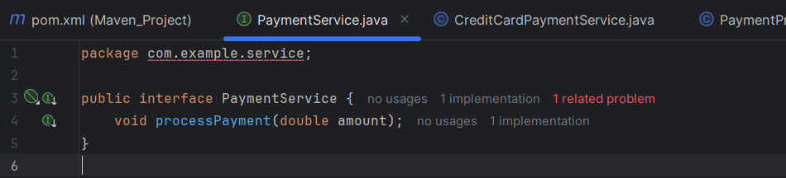

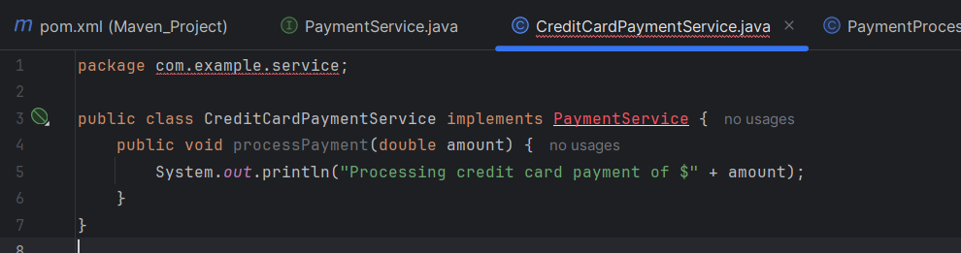

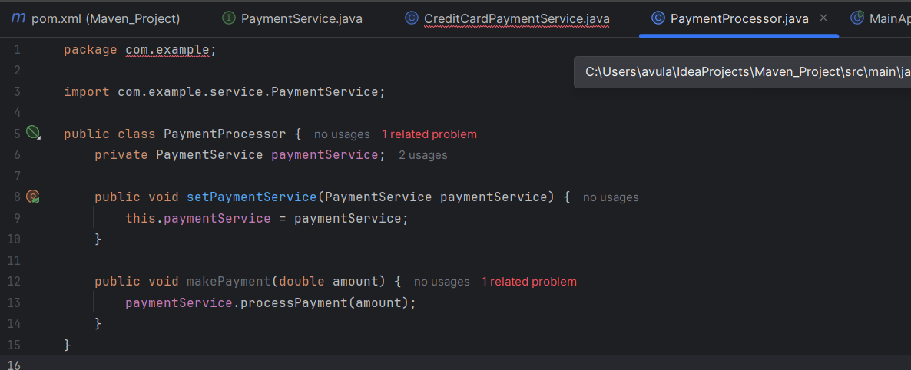

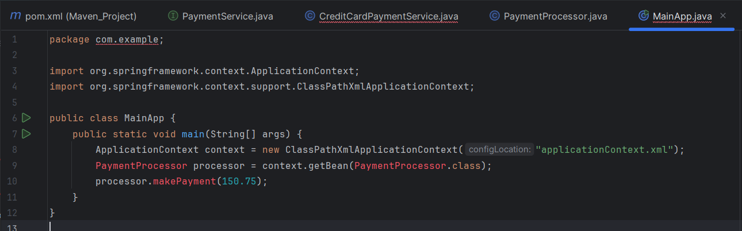

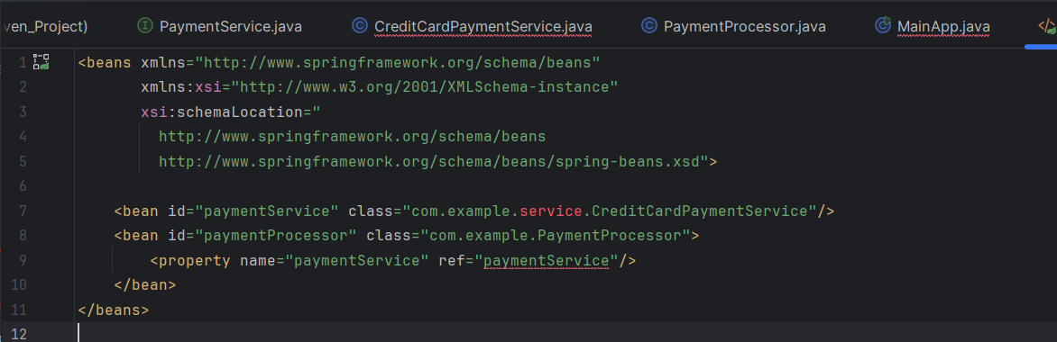

OUTPUT:

